| The Cuckoo’s Egg | 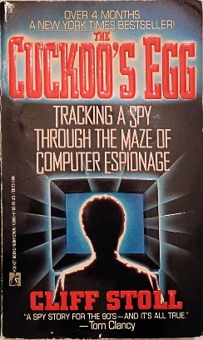
Cliff Stoll’s The Cuckoo’s Egg is a fascinating true story about tracking down a hacker in the early days of cybersecurity. It all starts when Stoll, working as a systems administrator at Lawrence Berkeley National Laboratory (LBL), notices a tiny accounting discrepancy—just 75 cents. What seems like a minor bookkeeping error turns out to be the trail of an intruder accessing U.S. government and military networks. Through persistence, creative problem-solving, and a bit of old-school hacking, Stoll uncovers an international espionage operation linked to the KGB. The book is part detective story, part history lesson, and a great look at the foundations of cybersecurity.
| My Impressions |
I really enjoyed this book, not just for its historical significance but for how well Stoll captures the curiosity and problem-solving mindset that makes cybersecurity so interesting. His writing is engaging (favorite word to use was bailiwick), and the way he methodically pieces everything together feels almost like a tech thriller—but it actually happened.
What made it even more interesting for me was getting to intern as a network engineer in the same server room at LBL where Stoll worked during this case. It was surreal to be in the exact place where one of the first real cyber investigations unfolded (I have the pictures to prove it!). That connection made the book feel even more real and relevant.
